Heroku

<https://mysurveyappconestoga.herokuapp.com/>

Google Analytic Screenshot

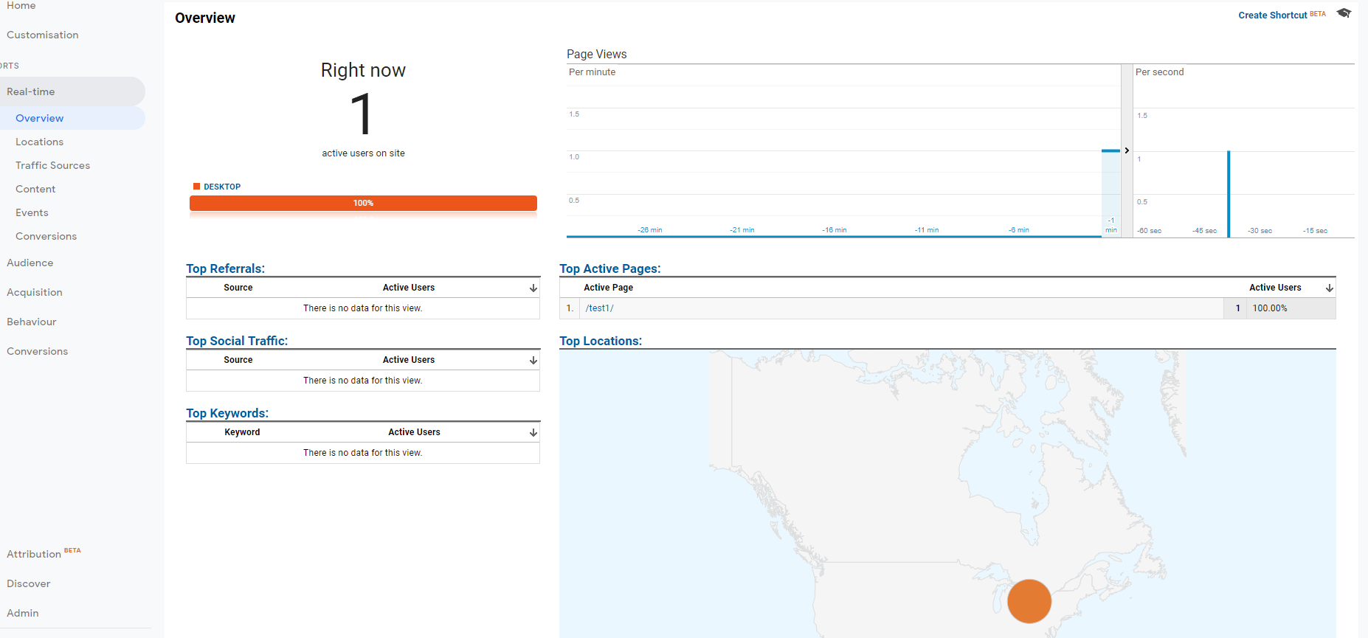

Google analytic on first thank you page

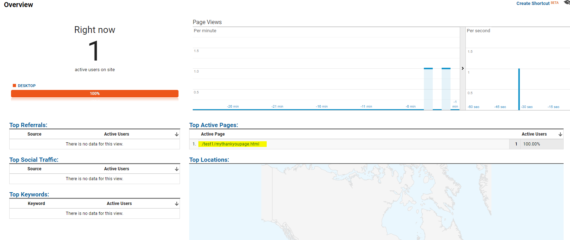

Second page analytics

